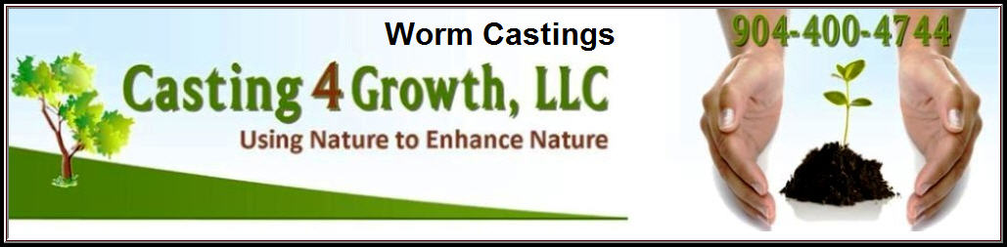
Benefits of Granular (Dry) Castings
- Safe and non toxic to children, pets, and wildlife. Use in the home is safe and orderless.
- Long term and sustainable solution to feeding and protecting lawns; castings insure soil building.
- Releases nutrients already in the ground and soil, but unavailable for use by the lawn. Castings achieve this by speeding up the decomposition rate of existing thatch and by ‘unlocking’ nutrients found naturally in the soil making them available for plants to use.
- Beneficial Nematodes: Castings contain beneficial nematodes that help eliminate destructive root eating nematodes and provide another source of nutrients for lawns.
- Insect Control: Several microorganisms found in worm castings work as effective repellants for a large number of insects. Microorganisms in worm castings naturally activate an enzyme produced by plants call Chitinase. Chitinase acts by dissolving Chitin, which is the main component of an insect’s exoskeleton.
- Fungus and Disease Control : Microbial life in castings eat destructive fungi and produce beneficial fungi.
- Weed Suppression : Castings build a thick and healthy lawn that will naturally choke out unwanted weeds ability to survive.
- Water Retention: Castings do an excellent job retaining moisture therefore making lawns and plants for resistant to drought and decreasing irrigation cost.
- Application of DRY (the natural casting) is needed only one time per year (spring) if a companion worm tea program is implemented. If worm tea is not applied at least monthly then a twice per year* (spring and fall) application rate for DRY should be followed.
- Castings build a healthy diverse soil and amend damaged soils.
- Castings will naturally aerate and soften soil.
- Castings do not contribute to any of the problems synthetic fertilizers are believed to have created. Such as the nitrogen run off or leaching into water table. Studies have shown only 25% of applied synthetic fertilizers are ever used by the plant.
- Dry castings can be applied at anytime or temperature without the worry of ‘burning’.
- Accidental over application of dry castings cannot ‘burn’ lawns or plants.
- No license needed to apply.

