5 GALLON WORM TEA BREWING INSTRUCTIONS www.CASTING4GROWTH.com
Materials Needed:
- 3lbs of Casting4Growth worm castings
- Casting4Growth D-9 Aerator
- 5 Gallon Brew Bucket (Not included with all kits)
- ¼ Cup UNSULPHURED MOLASSES
- High Quality Commercial Air Pump
- Bungee Cord

NOTE: The D9 Assembly kit can be purchased with/without the bucket. 5 gallon buckets are readily available at all home and garden centers.
D9 Assembly
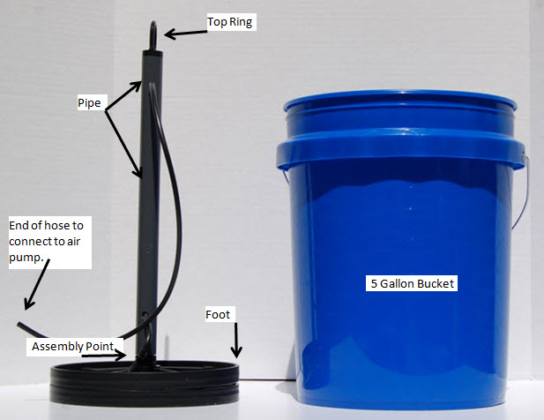
- Slide bottom end of long pipe over fitting located in the center of the D9 foot (Assembly Point). It is best to place the foot on a table and push down while holding the pipe in both hands since the pipe fits snuggly for a tight grip. (Do not push on Top Ring)
- Connect Air Hose coming out of the top side of the pipe to the air pump. This is a simple process of sliding the clear tubing over the brass extension on the pump. (not shown)
- Run Bungee Cord through ring on top of aerator and Secure bungee to each side of the bucket’s very top rim to keep aerator from floating during operation.
- Place air pump on a surface above water level.
Brewing Instructions:
1. Fill the bucket with water to be within 4" of the top. (If using chlorinated (city supplied) water, allow the aerator to run for at least 1 hour to 'off gas' the chlorine from the water before adding any molasses or castings.)
2. Mix ¼ cup of molasses into the Bucket. (This is best accomplished by stirring in a glass with water until dissolved. Use only unsulphured molasses.)
4. Distribute approximately 3lbs of Casting4Growth worm castings over the Bucket's bubbling surface. (Supplied castings weigh 5 lbs per package.)
5. Place the bubbling Bucket in a shaded area. Water temperature should be kept between 70ºF – 95ºF. (The brew will not have an odor (except the smell of sweet molasses) and produces no dangerous gases. It can be brewed in the home.)
6. Brewing takes 20-24 hours and the smell of molasses should no longer be detected. You should also have a foam head on the brew, which is a sign that your tea is highly active with microbial life. The tea is now ready and should be applied within 6 hours of this event.
Application Instructions:
1. Remove D9 Aerator from brew and then turn off the air supply. From the time the air is cut off you have approximately 6 hours to distribute all the tea to your plants. This time is important to honor as longer periods cause the microbes to die as their huge population consumes both the remaining food and the oxygen provided by the bubbler. Once on the plant, the grown microbes are fine for providing 4 to 6 weeks of vital contributions to your plants growth and health.
2. If applying via a sprayer, filter the tea by pouring through hosiery material or cheese cloth to eliminate clogs in sprayer nozzle.

For spraying large areas it is best to dilute the tea with water. Dilution to any extent is fine as long as you cover no more than 1 acre with the diluted solution. This allows the sprayer to work best when distributing the microbes evenly. For most yards, diluting is not required and the tea can be applied at full strength without any danger to plant growth. (Remember to always use un-chlorinated water. If un-chlorinated water is not available, then use the kit bubbles to off-gas the chlorine from a newly filled container for approximately 1 hour. An alternate to this would be to fill another 5 gallon bucket with chlorinated water when you start a new brew and let it sit for the 24 hours of brewing time.) When spraying, attempt to apply tea to both the top and bottom of leaves. The best time for spraying is during early morning or late afternoon when the sun is less intense. Do not water after spraying. This gives the tea microbes time to adhere to the leaf surface or proceed into the plant as determined by their specific purpose.
3. Filtering is not required, if applying as a soil soak (simply pouring the tea) around trees, large shrubs, potted plants, or trouble areas.
Clean up – getting ready for the next batch:
1. Use the residual organic material on the bottom of your brewer bucket by placing it around plants as you would dry worm castings. Again, if the organic material has been left for days in the brewer, insure there is no foul odor, and if so, do not use.
2. Thoroughly clean out worm tea brewer and its contents after each use with water to prevent harmful bacteria from forming.
- Remove any “bio slime” from the walls inside the brew bucket and let brewer air dry in sunlight.
- Spray off the bubbler foot to remove any loose organic material found on hose or in crevices.
- If unable to remove “bio slime”, peroxide or oxy-clean can be used to clean the brewer. If you use these products, be sure to let brewer dry before brewing again.
Repeat at least every 4-6 weeks. More frequent applications of up to once per week will help your plants thrive.
Trouble shooting: Why did the tea go bad? If you notice a foul odor, do not use the tea. It may have become anaerobic and harmful to your plants. Anaerobic microbes form in the presence of no oxygen and they are harmful and foul smelling. When you follow the directions above, you should not experience this problem unless you left the container for over 6 hours without the bubbler running. However, if you ever detect a foul odor, pour out the tea and do not use the residual organic material. Clean the brewer as instructed, let it dry in the sun, and then use it confidently again for a new batch.
- Is the water temperature between 70ºF – 95ºF?
- If using chlorinated water, was the water off gassed?
- Did you use ¼ cup of unsulphured molasses?
- Did you use 3lbs of worm castings?
- Did air pump turn off or become disconnected for a long period of time?
- Was brew left in direct sun light?
- Was brewer properly cleaned after previous use?
- Was it applied within 6 hours of removing the air pump?
- If you feel you did everything correctly and are still having problems, watch our instructional video at www.casting4growth.com, email us at casting4growth@gmail.com, or call us at 904-400-4744. We want to help!
Reasons Why “You Can't Grow it Better!”

- No Leaching or Run Off
- Superior Drought Resistance
- Decreased Irrigation Cost
- No Chemicals - Completely Safe to all persons/animals
- Low NPK footprint
- Plants / Grass Never 'Burn'
- Makes plants PH tolerant
- Natural Insect Repellant
- Odor Free
- Plants become more drought tolerant
- Lowers watering demand significantly
- Finest Soil Amendment Available
- Effective Disease/Fungal Suppression
- Nematode Suppression
- Healthier Stems & Fruit
- Largest Diversity of Microbial Life
- Creates an All Organic Environment
- Best Developer of Soil Humics
- Natural Growth Stimulator
- Thicker Root Structures
- Insect & Pest Suppression
- Use indoor / outdoor
- Safe to use during fertilizer blackouts

